**LIT TRAINING**

**Batch Name : SAP ABAP ON HANA** **DAY 12 ASSIGNMENT**

**EMPLOYEE ID – 46255438** **DATE : 17 September, 2022**

INTERFACE IN SFP

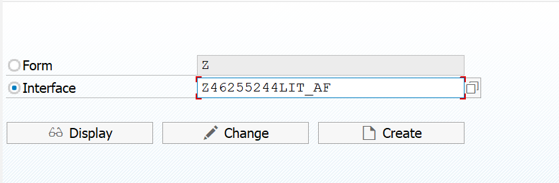

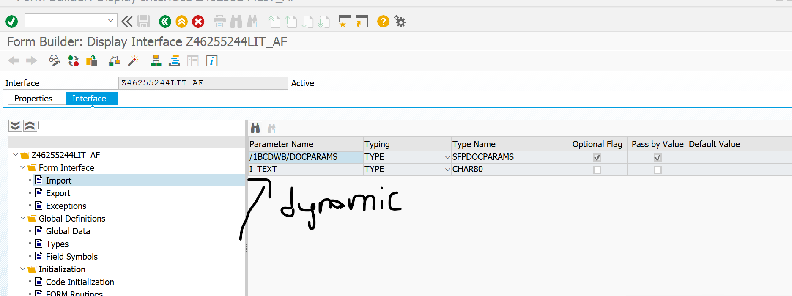

S_IMAGE FOR DATA DECLARATION OF SE-78 IMAGE

IT_TAB FOR IT_FLIGHT FIELDS DATA

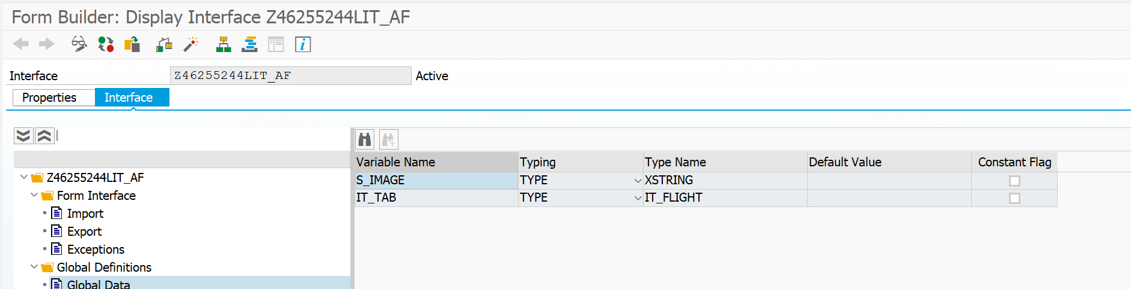

CODE FOR SFLIGHT DATA AND IMAGE

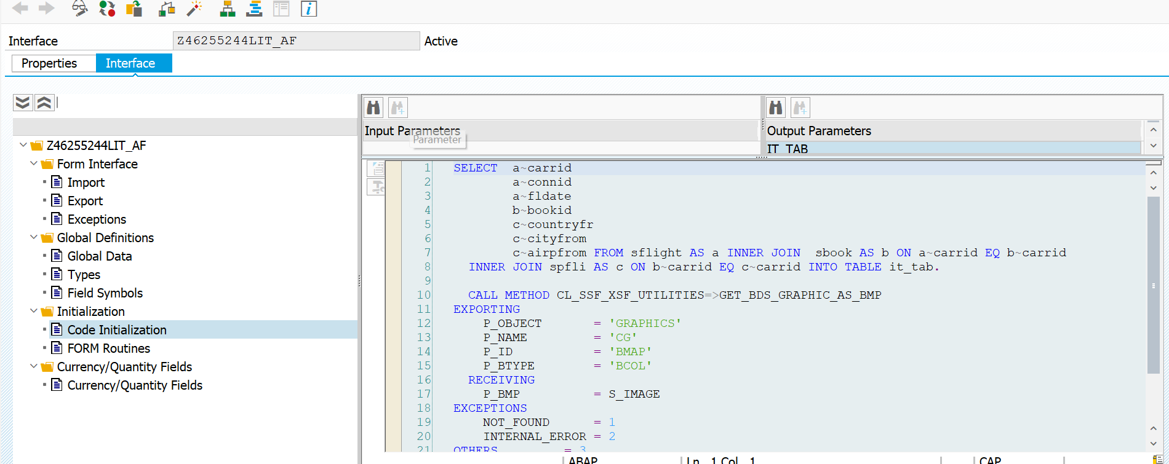

CREATION OF ADOBE FORM WITH CREATED INTERFACE

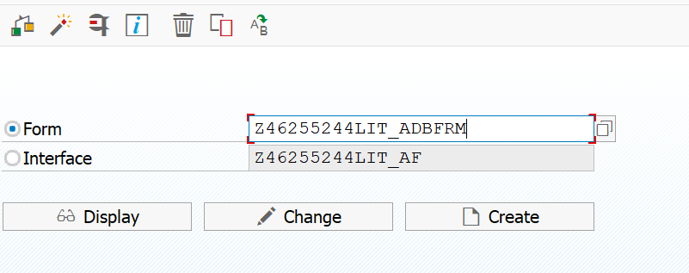

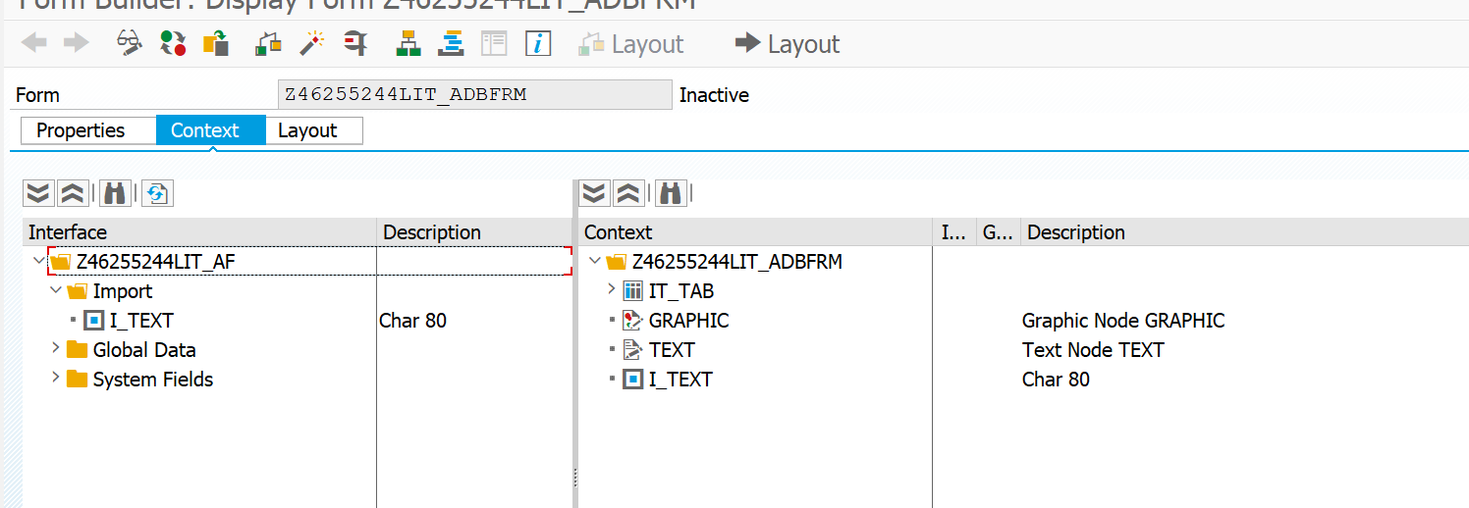

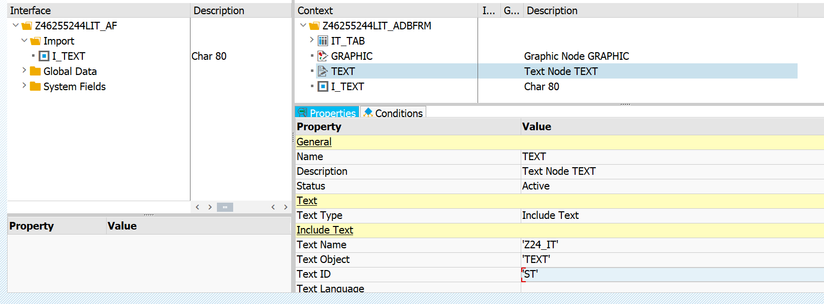

NOW GO TO LAYOUT

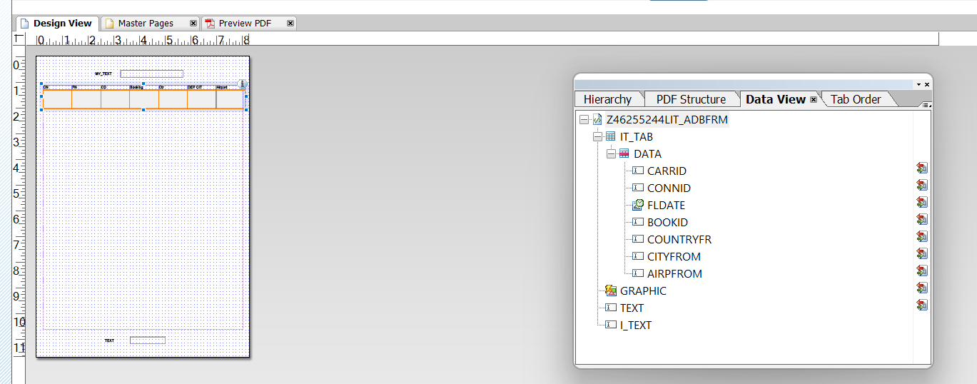

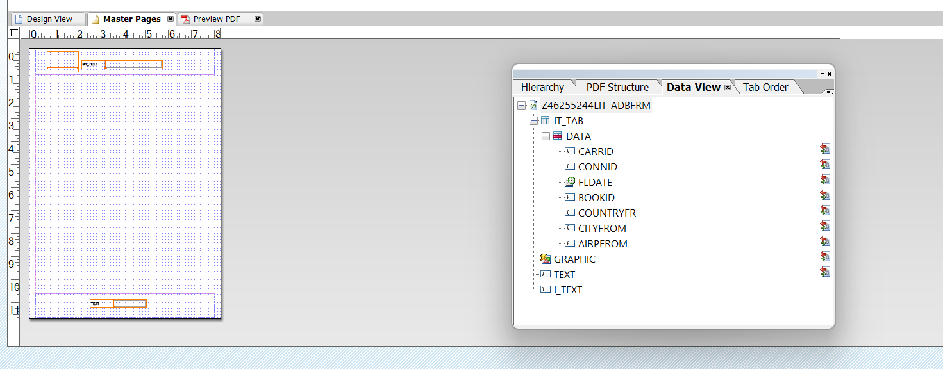

RESTRICTION LOGO AND DYNAMIC TEXT TO 1ST PAGE USING JS

var curpage = $layout.page ( ref ( $ ) )

if ( curpage ne 1 ) then

$.presence = "hidden"

endif

RESTRICTION FOOTER TO LAST PAGE USING JS

var curp = $layout.page ( ref ( $ ) )

var totalp = $layout.pageCount()

if ( curp ne totalp ) then

$.presence = "hidden"

endif

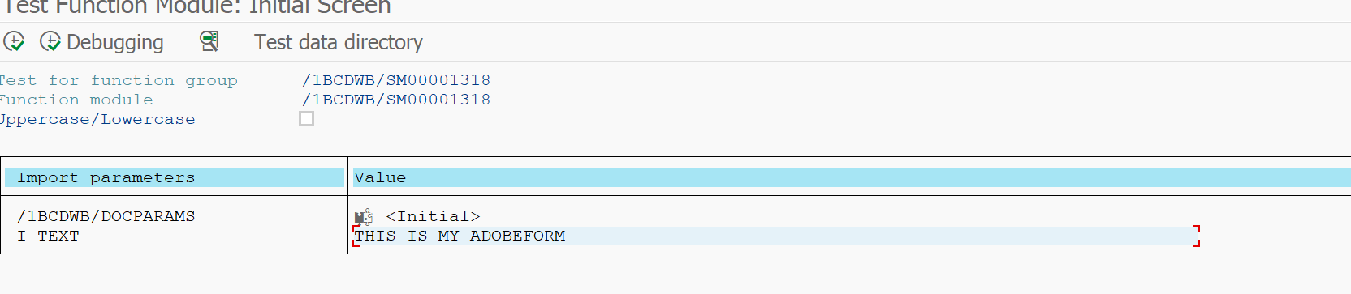

**OUTPUT:**

